¿Qué pasó
con los dedos de Pepe? 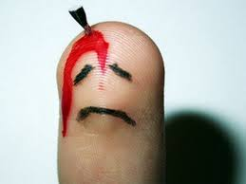
Mini – writing and illustration assignment 25 points

Para hacer:
- You and your partner will decide what happenened to Pepe´s fingers.
- You and your partner will write a short story using the preterite and imperfect.
- You and your partner will provide an illustration that goes along with your story.

Tu cuento (your story) needs:
- To be 15 FULL BIG SENTENCES mínimum
- Use preterite and imperfect
- Explain what happened to Pepe´s fingers!
- Tu cuento will start out
Hace muchos años…… A long time ago…..
- Your story will be typed
- Your illustration will be awesome, and colored and on paper that I give you.

Story – 15 points (graded on preterite and imperfect conjugations, logical story, general grammar and spelling)

Illustration – 10 points (graded on elaborateness, effort, color)

We will spend a period reading each other´s stories and voting on the best story of what happened to Pepe!

DUE: ________________________________

