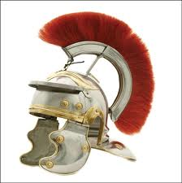
¡Ponte el casco!
Put on your helmet! Here it comes!
Tú Commands – Negative!
How to form negative Tú commands in Spanish
- Take infinitive Bailar
- Put the infinitive in the YO form Bailo
- FLIP! If the verb ends in ar – take off o and add ES Bailes
If the verb ends in er/ir – take off o and add AS
- Put NO in front and add exclamation points ¡No bailes! Don´t dance!
Don´t mix! Don´t eat! Don´t write!

Don´t sleep! Don´t order! Don´t heat up!

Don´t leave! Don´t do yoga! Don´t have ice cream!

Irregulars:
Dar = to give ¡Da! Give! ¡No des! Don´t give!
Ser = to be ¡Sé simpático! Be nice! ¡No seas antipático! Don´t be mean!
Ir = to go ¡Ve! Go! ¡No vayas! Don´t go!
Pregunta: Where do I put those little buggers????
Repuesta: With negative commands ALL pronouns go IN FRONT OF THE VERB

Example of reflexive pronoun Don´t get up! ¡No te levantes!
Example of direct object pronoun Don´t eat them! (manzanas) ¡No las comas!

Don´t shave! Don´t take a shower!

Don´t go to bed! Don´t get dressed!

Don´t get mad! Don´t feel sad!

Don´t wash it! (toalla) Don´t drink them! (refrescos)

