¿Es un robo? O ¿Es una ganga?

Costar (ue) means ___________________
- There are really only 2 forms of this verb
It costs ____________________________ dólares (dollars)
They cost ___________________________ dólares
- If you want to ask how much something costs you have 2 options as well
¿Cuánto cuesta? To ask how much is a single item. How much is it?
Ex: ¿Cuánto cuesta la mochila?
¿Cuánto cuestan? To ask how much is a plural item. How much are they?
Ex: ¿Cuánto cuestan los libros?
For each picture below
- Write the question: How much does ____ cost? or How much do ____ cost?
- Write how much the item costs in dollars
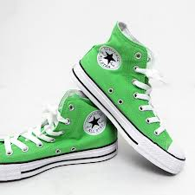A. B.
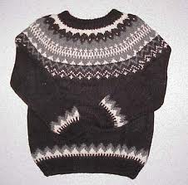A. B.
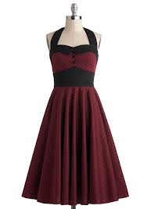A. B.

A. B.

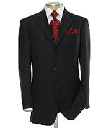A. B.

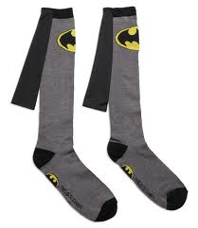A. B.

