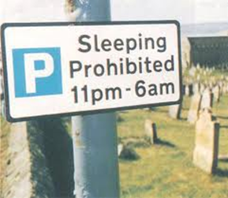

Anuncio assignment - 10 puntos
To do: using the impersonal SE, create a sign in Spanish that informs, prohibits, allows, sells, or is inspirational.
Need: message in Spanish (correctly using impersonal SE) and sign decoration
Graded on: Accuracy of Spanish and sign creativity and effort (did you put effort in or hurry up and do it?)
Due: Tuesday September 22nd!

