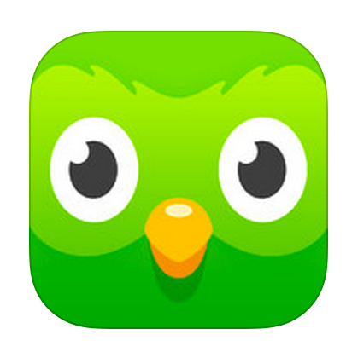
¡Aprendamos con Duolingo!

This year we will be supplementing our classwork with extra practice from Duolingo. Duolingo is an app that “gamifies” practicing and learning new Spanish. It is also great to practice building sentences, a skill that most Spanish students struggle with their first couple of years.

The game has two main “modes.” You can either learn and practice new material (vocab/grammar) OR you can practice material previously learned.

Each week, we will have a requirement for new material. On the opposite side of this page is a schedule for which “Skills” (Bubbles) you have to complete that week. They will be checked on the same day each week (FRIDAY END OF DAY). Students that do not complete them will lose 5 Pollo Pesos.

But I promise, if you take Duolingo seriously, it will help you. Let little Duo help.

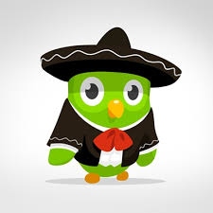
Week | Skills
1 | Basics 1 + Phrases
2 | Basics 2 + Food
3 | Animals + Possession
4 | Clothing + Questions
5 | Present 1 + Food 2
6 | Family + Sizes
7 | Household + Occupation
8 | Time + Adjectives 1
9 | Present 2 + Determiners
10 | Adverbs + Objects
11 | To Be + Places
12 | People + Object Pronouns
13 | Numbers + Past Tense
14 | Present 3 + Verb Infin. 1
15 | Ir Future + Countries
16 | Adjective 2 + Pronouns
17 | Directions + Education
18 | Vocab 1 + Participle
19 | Feelings + Present Perfect
20 | Past Perfect + Nature
21 | Vocab 2 + Verb Infin. 2
22 | Sports + Medical
23 | Gerund + Business
24 | Communications + Haber
25 | Spiritual + Future
Each remaining week | 50XP worth of training exercises

